Task 1:

RegEX Symbols in linux

**Common regex characters**

|  |  |
| --- | --- |
| . | Matches any single character |
| \ | Escape a special character |
| ? | The preceding character may or may not be present |
| * | Any number of the preceding character is allowed |
| + | One or more of the preceding character |
| | | “or”, match the preceding section or the following section |
| () | group a section together. This can be useful for conditionals or to create groups for substitutions |
| {} | Specify how many of the preceding character |
| [] | Match any character in this set. - defines ranges ^ means “not” |
| ^ | Beginning of line |
| $ | End of line |

**Character shortcuts in regex**

In most regex implementations, you can use backslash followed by a letter (\x) as a shortcut for a character set. Here’s a list of some common ones from [rexegg.com’s regex cheat sheet](https://www.rexegg.com/regex-quickstart.html).

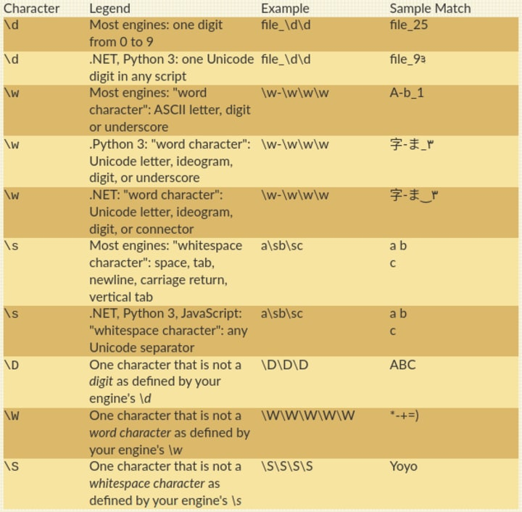

Task2 :

Features of Linux:

Open-Source Foundation

Multiuser and multi tasking

Robust security measures

Portability and Customization

Stability and reliability

Community support

Package management

Command Line interface

Graphical user interface

Free of cost

Freedom to Modify

Task 3:

Kernel: Kernel in linux is a intermediary between hardware and software. It manages system resources, handles process, memory and facilitates communications. It handles things like CPU time, disk access etc.

Task 4:

BASH stands for Bourne Again SHell. It's a powerful command and line interpreter and scripting language, used for interacting with the operating system. Bash is the default shell on many Linux distributions and is also available on macOS.

Task 5:

Difference between Linux and windows

|  |  |
| --- | --- |
| Linux | Windows |
| More Flexible | Less Flexible |
| More Customizable | Less Customizable |
| Strong security | Weak Security |
| Non User Friendly | User Friendly |
| Not widely supported | Widely supported |

Task 6:

Basic components of linux:

The core components of a Linux operating system include the kernel, system libraries, and system utilities.

Other Components:

Bootloader, Init system, Shell, desktop environment and applications.

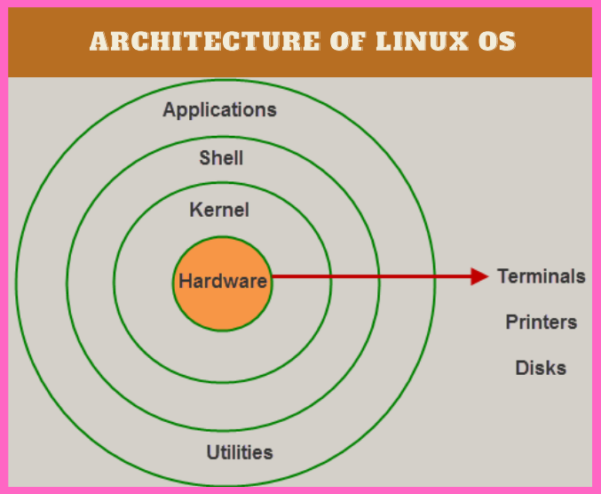

Task 7:

Yes, it is legal to edit kernel due to its open-source nature under the GNU General Public License.

The license allows us to modify under license terms

Modifications like: Customization, bug fixes, performance optimization, security enhancements and Driver development.

Task 8:

Linux Loader is a legacy bootloader used in Linux systems to load the operating system kernel during the boot process. It was a common bootloader in older Linux distributions, but is now largely replaced by GRUB. LILO allows users to select different operating systems installed on a computer during boot.

Task 9:

Shell:

Shell acts as a interface between user and the operating system. It interprets commands entered by the user and executes them to give a output.

Types of shell:

CLI – Command In line shell: Provides a text-based interface where users interact with the OS by typing commands. Examples include Bash, which is widely used in Linux and Unix systems. Other CLI shells include sh , csh and zsh.

GUI- Graphic User Interface: These shells offer a visual interface with menus, icons, and windows, making it easier for users to interact with the OS. Examples include Windows Explorer, which is the default shell for Windows operating systems.

Task 10:

Swap space is also known as virtual memory, which acts as an extension of RAM in the ssd or hard disk. It is used when the ram is full to avoid crashing due to less memory.

Task 11:

Mount:

In Linux, "mount" refers to attaching a filesystem like a USB to the directory tree, making it accessible to the operating system and users. The mount command is used for this purpose, while the umount command is used to detach or unmount a filesystem.

Task 12:

Chmod command is used to alter the permission of a file or folder to a user or group or everyone. It is basically assigned as 4 for read, 2 for write and 1 for execute.

Numeric Mode (Octal):   
**chmod 777 filename:** Gives full read, write, and execute permissions to the owner, group, and others.   
**chmod 755 filename:** Gives read, write, and execute to the owner, and read and execute to the group and others.   
**chmod 644 filename**: Gives read and write to the owner, and read only to the group and others.   
Symbolic Mode:  
**chmod u+x filename**: Adds execute permission to the owner.   
**chmod g-w filename:** Removes write permission from the group.   
**chmod o+r filename:** Adds read permission to others.

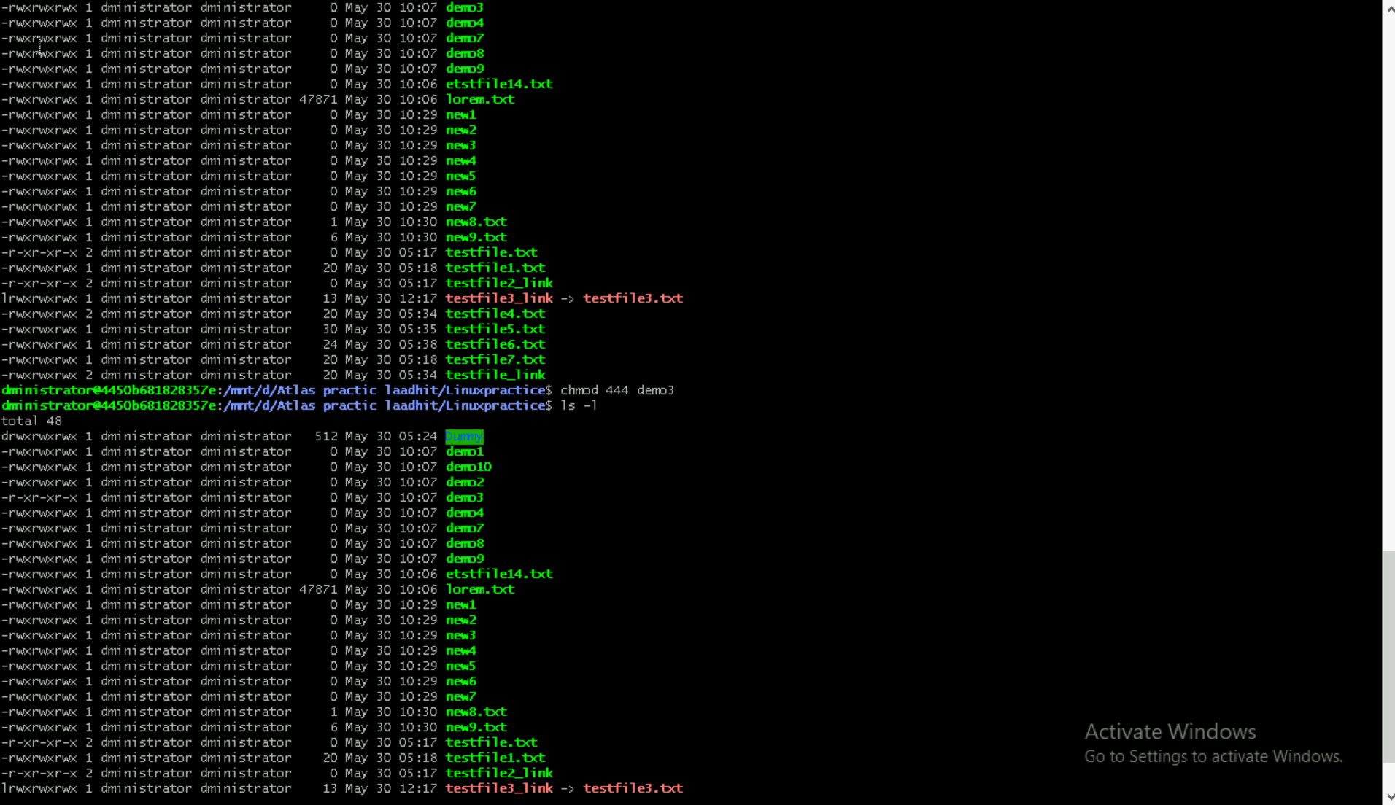

Task 13:

Create a new user

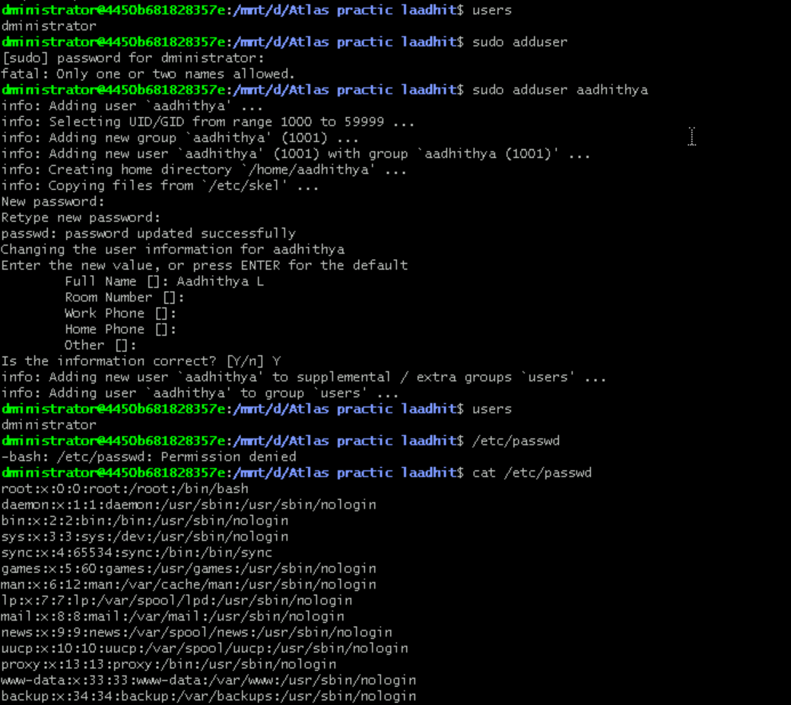

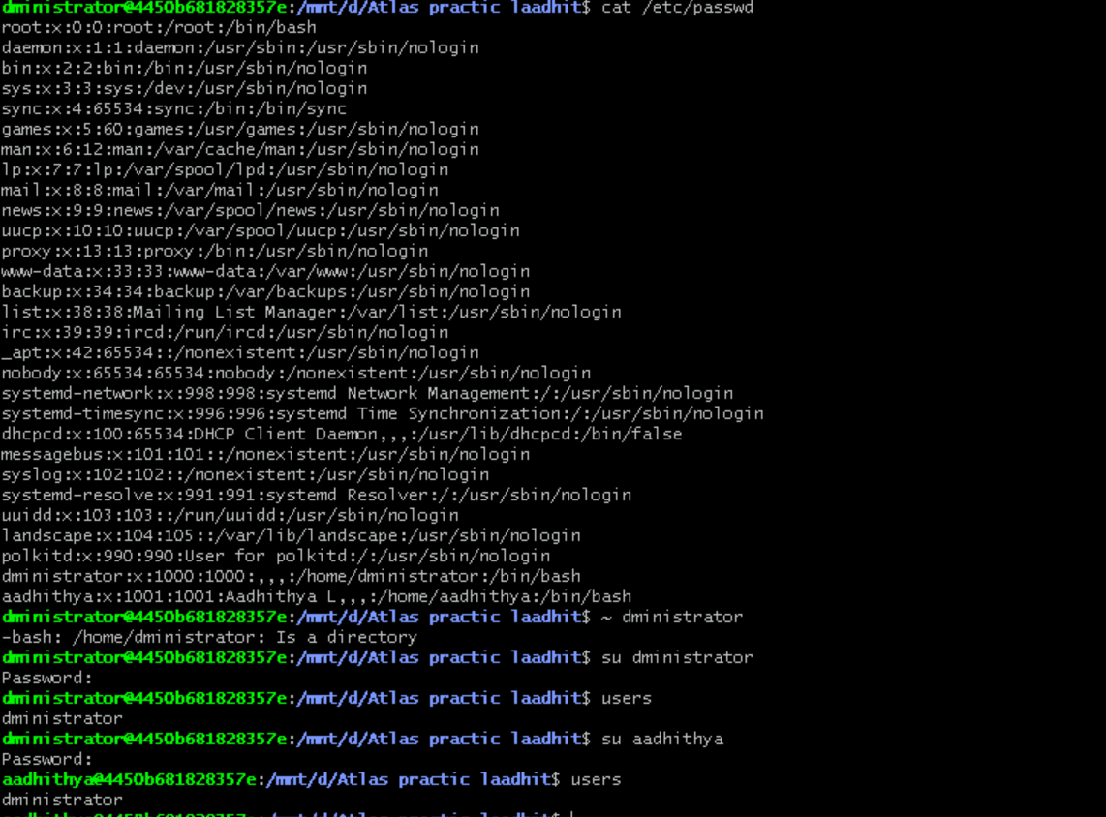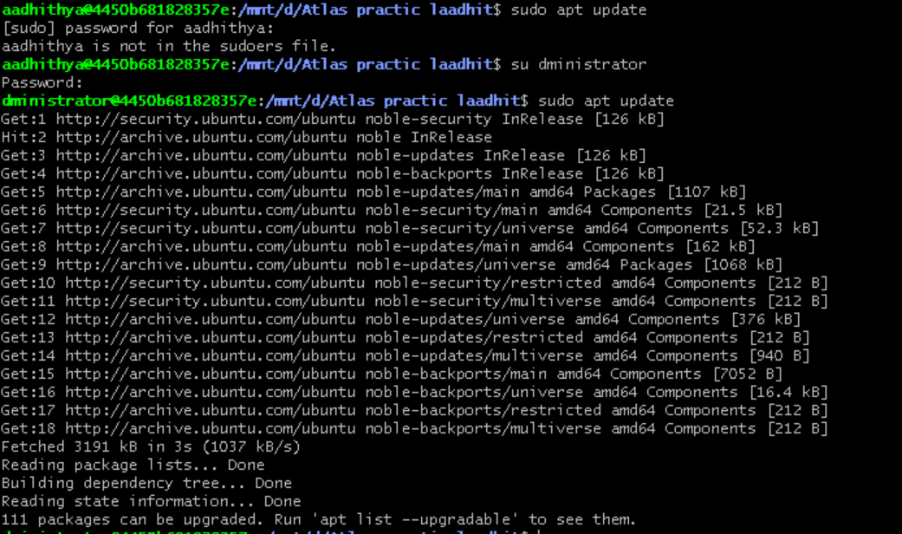

Task 14:

Can you change the password of a user? Yes

How do you do that? Use passwd command and change the password.

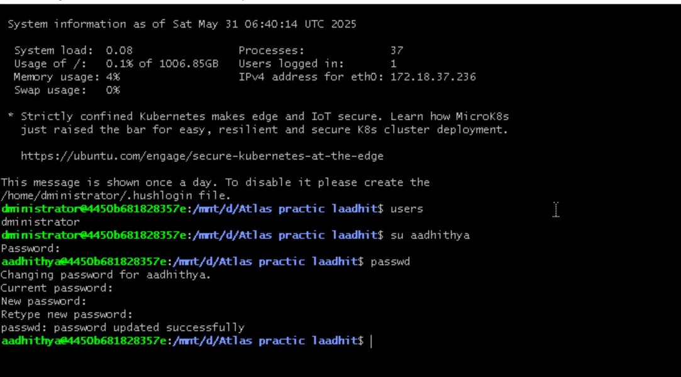

Task 15:

Difference between process and thread:

A process is a program in execution, while a thread is a unit of execution within a process. Processes are independent, with their own memory space, while threads within the same process share memory and resources. Threads are lighter than processes, meaning they require fewer resources and have faster context switching.

Task 16:

Grep commands

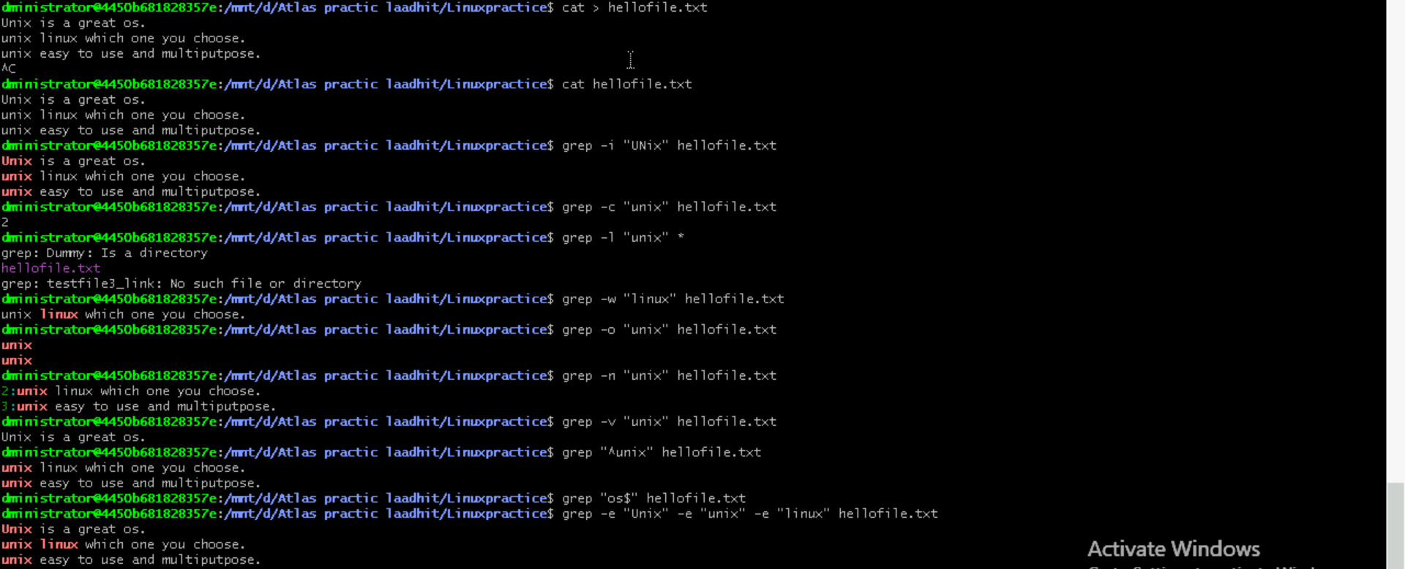

Task 17:

Awk commands:

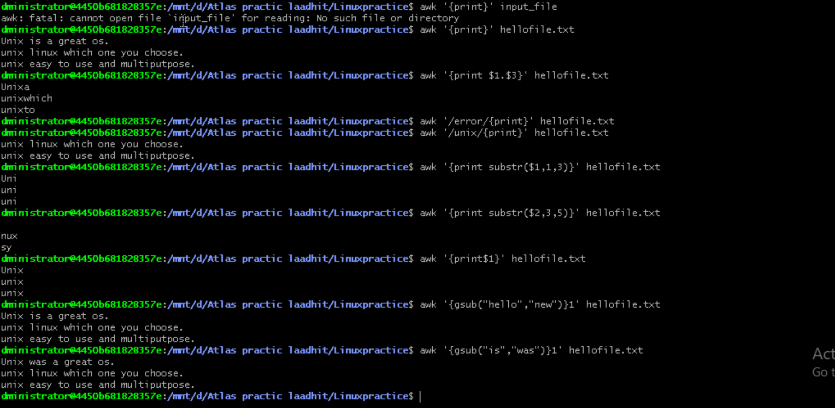

Task 18:

Ls -l

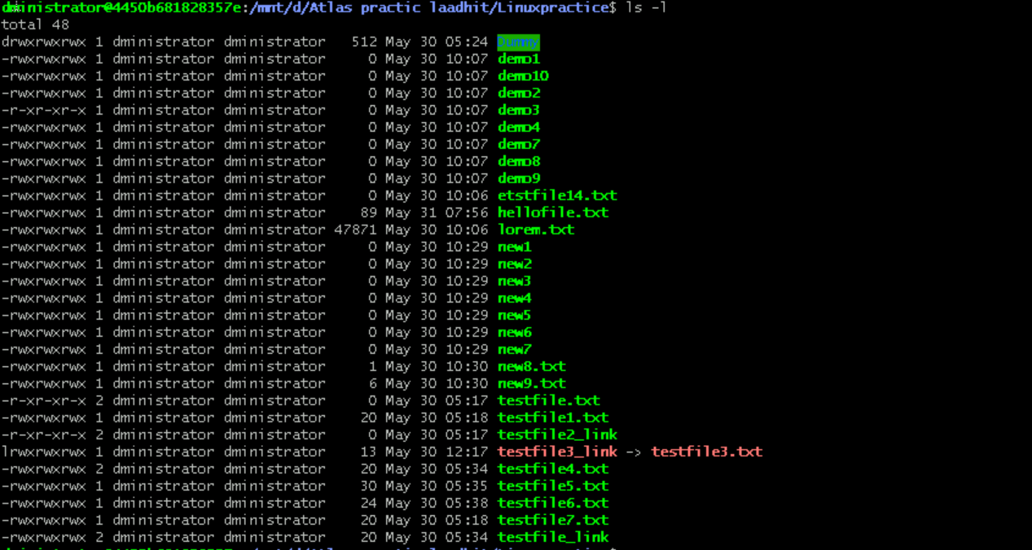

Task 19:

What are the default permissions for a new file ?

Rw-rw-r

Task 20:

What is the command to change the permisssion to read only for the owner, group and all other users

Chmod 444 testfile.txt

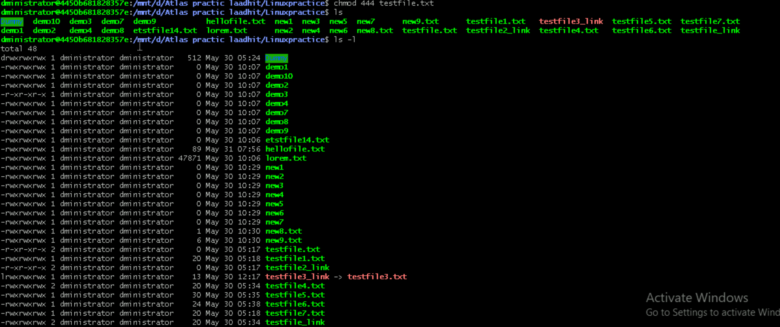

Task 21:

Can you change the file permissions to match the following:

* owner: Read and Write
* group: Read

other: no permissions (None)

Yes by using the command **chmod 640 filename.txt**

Task 22:

What was the command for changing the file permissions to -rw-r-----?

Chmod 640 filename.txt

Task 23:

Change chmod.exercises permissions to -rwxr-x—x

Chmod 751 filename.txt

Change the file permissions to match the following:

owner: Read, Write and Execute

group: Read and Execute

other: Execute

chmod 751 filename.txt

Task 24:

What was the command for changing the file permissions to -rwxr-x--x

Chmod 751 filename.txt

Task 25:

Guys what will this command do?

chown -c master file1.txt  
chown will change the ownership from one user to other user, the above command will change the user of file1.txt to master

Task 26:

Can you define what is  a process

Process is a running instance of a program. It is an active entity system manages and utilize resources like cpu, storage etc.

Task 27:

What is command to check foreground process and background process : Ps

Task 28:

Can you list all the running processes? 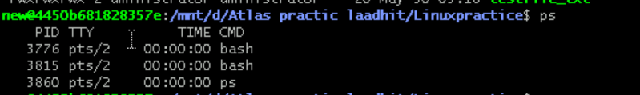

Task 29:

Ps -f

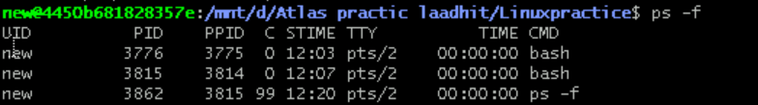

Task 30,31,32:

Create a name using variable name

